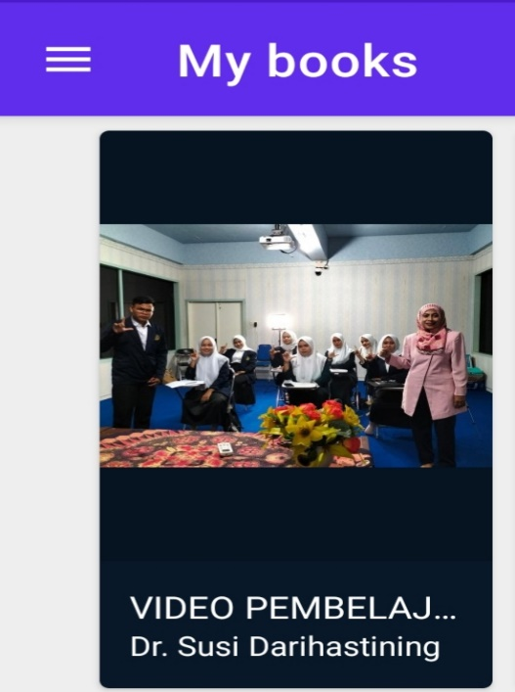
Figure 2.2 Teaching Video of Microteaching Report (Students’ creativity using E-PUB application) https://youtu.be/F0uxeE1RjQE

