AGRISAINTIFIKA
- JURNAL ILMU-ILMU PERTANIAN -
Fakultas Pertanian - Universitas Veteran Bangun Nusantara Sukoharjo
Jl. Letdjen S. Humardani No 1 Sukoharjo Jawa Tengah, Indonesia
Telp. (0271) 593156
E-mail: agrisaintifika@gmail.com
Web: http://jurnal.agrisaintifika-fpunivet.ac.id

Statement of Originality
Submitted to the
AGRISAINTIFIKA

Title of the manuscript : Inovasi Batik Mangrove Brebesan sebagai Dasar Penguatan Budaya Lokal Kabupaten Brebes
Authors : ¹⁾M. Dini Adita, ²⁾Mohammad Jusuf Randi

As the corresponding author I certify that this manuscript is original and its publication does not infringe any copyright.
As the corresponding author I declare that the manuscript has not been previously published, in whole or in part in any other journal or scientific publishing company. Also the manuscript does not participate in any other publishing process.
As the corresponding author I declare that all persons listed hereafter were committed in the creation of the paper and were informed about their participation.

Brebes, 14 November 2019
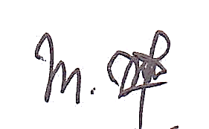

M. Dini Adita

^{*)}This statement must be upload for supplementary files while submitting your manuscript
or sent back to agritech@ugm.ac.id email or fax (0274) 589797.

