Development of E-Supplement Teaching Materials Physics
Based On Flipbook in Balogo Traditional Games

Afifah Khansa Nadhiroh ¹, Trapsilo Prihandono ², dan Singgih Bektiarso ³
Pendidikan Fisika, Fakultas Keguruan dan Ilmu Pendidikan/Universitas Jember, Jember, Indonesia
E-mail: ¹afifahkhansa6@gmail.com*, ² trapsilo.fkip@unej.ac.id , ³singgih.fkip@unej.ac.id

ABSTRACT

Indonesia is a country rich in cultural diversity that is spread in every region, one of which is traditional games. The existence of traditional game from time to time began to eroded and forgotten among children. Along with the development of the times, educators must follow the development of existing technology and not forget the cultural values ​​of the local area. The existence of traditional games can be maintained by introducing and integrating them into learning through teaching materials. Therefore, this research is focused on the development of e-suplement teaching materials physics based on flipbook in balogo traditional games. This research aim to determine the validity and feasibility of e-suplement teaching materials physics based on flipbook in balogo traditional games. This research uses the research and development method od 3D models (define, design and develop) modified Thiagarajan’s 4D models. The results of research indicates that e-suplement teaching materials physics based on flipbook in balogo traditional games is very good with validity 91,36%. The concluded is e-suplement teaching materials physics based on flipbook in balogo traditional games valid and very feasible for use in learning.

Keywords: Example: feasibility, suplemen teaching materials, traditional game, validity

INTRODUCTION
Indonesia is a country rich in cultural diversity, ethnicity, and customs that other countries do not have. One of the cultural diversity heritages in Indonesia is traditional games. the existence of traditional games from time to time began to erode and be forgotten. Traditional games are fading away due to the development of the era of digital technology and the influence of globalization (Suryawan, 2020). Balogo is a traditional game that is popular in the Banjar tribal area, precisely in South Kalimantan. Balogo games also have a process of inculcating cultural values, namely honesty, cooperation, hard work and deliberation (Azahari, 2018). Based on an interview with Dra. Hj. Siti Nursiah Se.Ak., the tradition of local wisdom in the balogo game was eroded and revived by holding a socialization of balogo to reintroduce it to the younger generation.
Efforts to preserve local culture to keep it intact and awake are by introducing and implementing the balogo game in the world of education. The integration of local culture in learning can motivate students to develop knowledge, build understanding and perceive the relevance of the material taught by educators during the learning process (Kristin, 2015). Educators also still have not integrated culture in learning so that educational goals are lacking in achieving educational goal (Shufa, 2018). Learning that does not collaborate scientific literacy into real environmental knowledge can cause students' scientific knowledge to be low and tend to be rote. Learning by integrating indigenous science processes (culture) into scientific science can create a more meaningful learning atmosphere (meaningfull learning) and students are more active in analyzing and exploring problems in the local area. Culture-based learning is more meaningful because it can relate learning materials to everyday life (Sumalong et al., 2021). Local culture-based learning can be implemented on science concepts, namely physics. Physics is a science that is closely related to human life and natural phenomena (Harefa, 2019).
Quality learning can be realized by packaging physics teaching materials that integrate culture. Efforts to incorporate cultural values ​​into education are designing, creating, and developing teaching materials (Ferdianto & Setiyani, 2018). Teaching materials are media to achieve learning objectives so that students can understand the material presented by educators. The teaching material developed in this research is an electronic supplement book, which is abbreviated as e-supplement. Supplementary books are learning support books that contain facts, information, and various things that aim to help the main textbooks according to the material and needs of educators (Pranata et al., 2021). Along with the times, educators must keep up with technological advances by using teaching materials that can be accessed online. Flipbook-based teaching materials can be an alternative solution in supporting student learning in the era of the industrial revolution 4.0 following increasingly rapid technological developments. The use of flipbook-based teaching materials can improve understanding of student achievement (Kodi et al., 2019). Flipbook-based physics teaching material e-supplements not only provide text readings but also animations, videos, illustrations, audio with tools that allow users to interact so that the learning atmosphere is more interesting and not boring. E-Supplements for flipbook-based teaching materials are designed to overcome boredom and make it easier for students to understand the material taught by educators so that learning can run effectively (Adrian & Laila Agustina, 2020).
Similar studies were carried out by other researchers, including by (Nugroho et al., 2021) which resulted in the development of supplementary teaching materials based on local wisdom that were proven to be very valid, interesting, good and practical so that teaching materials were suitable for use in learning. Furthermore, similar research was conducted by (Marditha et al., 2022) which resulted in the development of supplementary teaching materials based on local wisdom of the Pasti Jaya Village community which proved to be very suitable for use in terms of material, language and graphics. The novelty of this research is that the supplement of physics teaching materials is packaged in electronic form using a flipbook that contains local wisdom of the traditional Balogo game culture. Based on the facts above, researchers need to develop an e-supplement to flipbook-based physics teaching materials in the traditional game of balogo. This study aims to determine the validity or feasibility of an e-supplement to flipbook-based physics teaching materials in the traditional Balogo game.

METHODS
This research was conducted using the Research and Development (R&D) method with an ethnographic approach. Ethnography is a systematic description and analysis of the culture of the local community in order to understand a view of life through the point of view of that culture (Siddiq & Salama, 2019).
- Product Development Model
The product development model is a descriptive procedural model. The product development model is an e-supplement to flipbook teaching materials based on the traditional Balogo game that can be accessed online and supported by computer technology or mobile devices. The e-supplement for flipbook teaching materials was made with the help of flipHTML 5 software.
- Product Development Method
The method of developing an e-supplement for flipbook teaching materials based on the traditional balogo game used is the Research and Development (R & D) method with a 3D model. This research and development method consists of define, design and develop a modified Thiagarajan 4D model. The Research and Development (R&D) method is a process used to develop and validate educational products (Sriwahyuni et al., 2019).
- Data Analysis Techniques
Data analysis techniques to determine the validity of the e-supplement flipbook teaching materials through 3 stages, namely material experts, media experts and users. Determine the value of expert validation from the average indicator with the equation:
$$V_{a}= \frac{{Ts}_{e}}{{Ts}_{m}} x 100\%$$
Information :
$V_{a}$ is expert validation (material, media dan users)
${Ts}_{e}$ is the total score obtained from the validator
${Ts}_{m}$ is the maximum expected total score
The combination of the validation results from the assessments of media experts, material experts and users can be determined by the average equation as follows
$$\overline{V_{a}}= \frac{V_{a1}+ V_{a2}+ V_{a3} }{3}$$
Information :
$\overline{V_{a}}$ is the value of the validation result
$V_{a1}$ is the material expert validation value
$V_{a1}$ is the media expert validation value
$V_{a1}$ is the user validation value
The qualifications for the feasibility of flipbook teaching material e-supplements to change the quantitative value from the validation results into qualitative values ​​based on 5 categories of assessment can be shown in Table 1.
Table 1. Eligibility qualifications for flipbook e-supplements
Nilai | Score Range | Category
A | 81% ≤ x < 100% | So worth itu
B | 61% ≤ x < 80% | Decent
C | 41% ≤ x < 60% | Quite decent
D | 21% ≤ x < 40% | Not Worth it
E | 0% ≤ x < 20% | Very unworthy
(Taufiqy et al., 2016)

RESULTS AND DISCUSSION
The resulting research and development product is an e-supplement to flipbook-based physics teaching materials in the traditional Balogo game. The research aims to produce an e-supplement for flipbook-based teaching materials that are valid and suitable to be used as additional teaching materials in physics learning. The limitation of this research is the third stage of the Borg & Gall research procedure, namely the validation and revision stages of the experts.
- Developed Product Analysis
Before designing teaching material products, field observations are needed regarding potential problems and student needs. The observation phase was carried out in one of the public high schools (SMA) in the city of Jember. Based on observations in the field, students are very interested in the development of increasingly sophisticated digital technology because it makes it easier for students to find various information according to their needs. In increasing students' interest in learning and creating new situations in learning, educators must prepare teaching materials that are favored by students. Some physics teachers also have never applied flipbook-based physics teaching materials in learning because they are still guided by printed teaching materials and teaching materials in high school also do not integrate culture (original science) into scientific science.
Flipbook-based physics teaching materials are very effective and practical, they can be carried anywhere without having to burden students with carrying printed books. Effective teaching materials can improve the quality of better learning so that better student learning outcomes can be achieved (Reizal et al., 2020). The development of teaching materials must pay attention to the curriculum that applies in learning, the characteristics of students and can guide students in solving problems while keeping abreast of technological developments (Sari et al., 2021). Therefore, in supporting learning with limited digital teaching materials, researchers are interested in developing an e-supplement for flipbook-based physics teaching materials that integrates the traditional game culture of Balogo.

- Teaching Material Design
At this stage, the process of compiling teaching materials is carried out by collecting various information about the traditional game of balogo (original cultural science) which is integrated into physics (scientific science) as the main material for e-supplement to flipbook-based teaching materials. E-Supplements for flipbook-based teaching materials that integrate local wisdom of the balogo game provide something new to students in teaching and learning. The design of this teaching material consists of several components including cover, identity of teaching material supplements, introduction, table of contents and pictures, achievement indicators, instructions for using supplementary teaching materials, concept maps, material descriptions, practice questions and bibliography. The development of good teaching materials consists of title components, learning materials, competency standards, basic competencies and indicators, learning objectives, instructions for using teaching materials for students and teachers, supporting information, worksheets and assessments (Febrina et al., 2020).
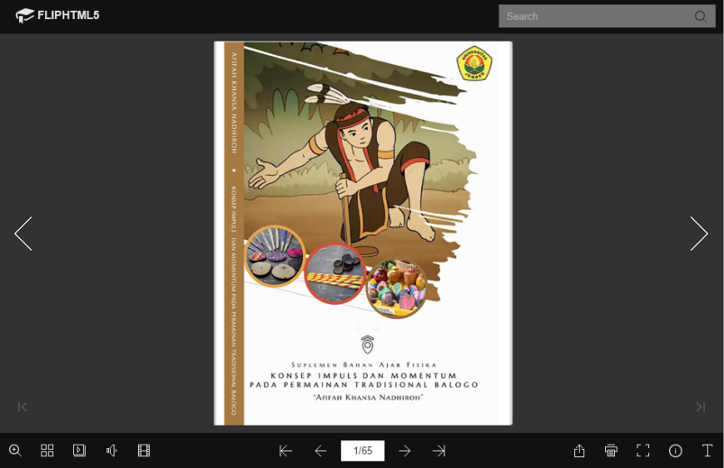
Figure 1. Cover of Flipbook-Based Physics Teaching Material Supplement
The cover section of the teaching material supplement in Figure 1 shows the title of the teaching material supplement with several color combinations. The cover color of this teaching material supplement is designed to give an impression related to the balogo game made from coconut shells so that the brown color is very appropriate to be the basic color of the teaching material supplement. The supplementary cover of teaching materials will be more interesting with animated depictions related to the balogo game. One of the criteria for good teaching materials includes learning outcomes, is relevant to competency standards, has attractiveness and motivation, includes aspects of knowledge based on facts, concepts, principles and procedures, is systematic, and practical (Magdalena et al., 2020). The display of the contents of the teaching materials can be shown in Figure 2 which is arranged based on the achievement of learning physics in accordance with the Content Competencies and Basic Competencies.
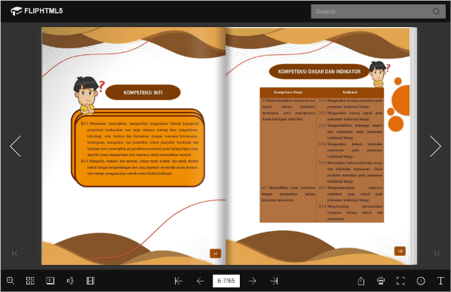
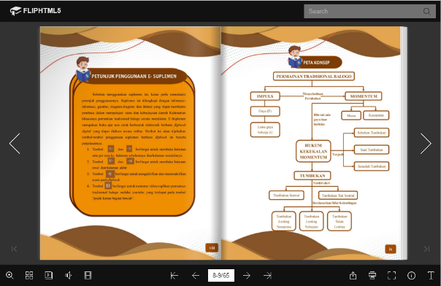

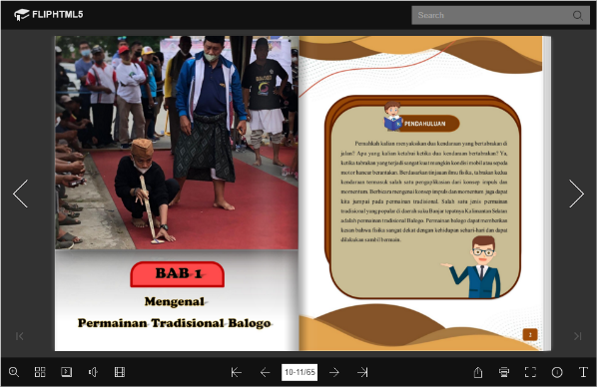
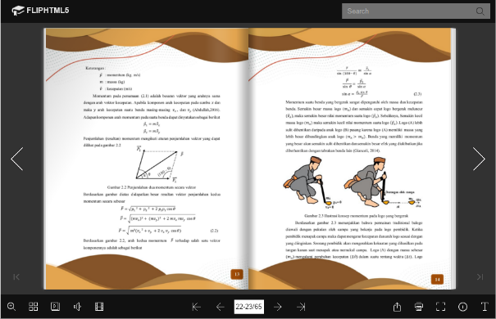

Figure 2. Display of Achievement Indicators for Teaching Material Supplements,
Instructions for Teaching Materials, Concept Maps and Material Descriptions

- Expert Validation
The validation of teaching materials is an assessment that aims to measure the truth of the data, validity, and feasibility of teaching material products based on the content of the material and the display design of the developed product. The validation of the flipbook-based physics teaching material e-supplement was carried out to determine the level of product feasibility. The validation of teaching materials was carried out by 9 validators consisting of 6 physics education lecturers, FKIP Jember University and 3 user validators, namely high school physics teachers. The assessment is carried out on three aspects, namely the material, media, and user aspects.
Table 2. Results of Material Aspect Validation Test (Source: Research Data)
Validator | Score | Max Score | Strength
Expert 1 | 50 | 56 | 89,29 %
Expert 2 | 50 | 56 | 89,29 %
Expert 3 | 50 | 56 | 89,29%
Averange |  |  | 89,29 %
Based on table 2, the first stage regarding the material aspect obtained a percentage of validity of 89.29% which shows the criteria are very valid. The components of the assessment in the material aspect are the feasibility of the content and the feasibility of presentation. First, the feasibility of the content consists of 3 indicators, namely 1) the scope of the material, 2) the accuracy of the material, and 3) the up-to-dateness of the material. Second, the assessment of the feasibility of the presentation, namely the technique of presenting the material and supporting the presentation of the material. The flipbook-based physics teaching material e-supplement is categorized as very valid with several suggestions for improvement that need to be followed up. One of the suggestions given by the material validator is that the writing of physics symbols is more clarified, the presentation of sentences that generate motivation is less, deepens the material so that it is more detailed. The completeness and correctness of the content related to the material must be adjusted based on Core Competencies (KI) and Basic Competencies (KD) so that the expected learning objectives can be achieved. In addition, the components of the presentation of the material are arranged systematically and the teaching materials contain scientific literacy. The use of language is clear, logical, communicative and adapted to good and correct Indonesian rules (Kapitan et al., 2018). The use of language can provide a stimulus so that the level of readability of teaching materials is easily understood by students. Teaching materials designed by adding illustrations, pictures, and animations can be a motivational generator for readers so as to increase the interest and interest of students (Rahmayantis & Nurlailiyah, 2020).
Table 3. Results of Media Aspect Validation Test (Source: Research Data)
Validator | Score | Max Score | Strength
Expert 1 | 101 | 108 | 93,52 %
Expert 2 | 97 | 108 | 89,81 %
Expert 3 | 97 | 108 | 89,81 %
Averange |  |  | 91,05 %
Based on table 3, the second stage regarding the media aspect obtained a percentage of validity of 91.05% which shows the criteria are very valid. The assessment component in the media aspect consists of two components, namely the feasibility of the content and the feasibility of presenting the media for teaching materials. First, the content feasibility component consists of 5 indicators including 1) artistic and aesthetic, 2) the ability of informative teaching materials and fosters the curiosity of readers, 3) systematic presentation, coherence, logicalness, and conceptual confusion, 4) supporting material presentation, and 5) linguistic eligibility. Second, the presentation feasibility component is divided into 2 indicators, namely 1) presentation technique, and 2) presentation accuracy and suitability. There are suggestions for improvement related to the presentation of e-supplement media for flipbook-based teaching materials regarding the alignment of background color with writing, typography improvements, and cover design improvements. The manufacture of teaching materials needs to pay attention to graphics, the completeness of layout elements, color combinations and the use of proportional fonts (Agustin et al., 2019). The design principles in the design of teaching materials that must be considered include illustrations, colors, typography, shapes, and messages (Badri, 2020). The selection of typography plays an important role in adding to the curiosity of the reader so that the presentation of e-supplement teaching materials does not only contain reading texts.
Table 4. Results of User Validation of Teaching Materials (Source: Research Data)
Validator | Score | Max Score | Strength
Expert 1 | 62 | 64 | 96,88 %
Expert 2 | 57 | 64 | 89,06 %
Expert 3 | 61 | 64 | 95,31 %
Averange |  |  | 93,75 %
The third stage is regarding the user aspect with several components that are assessed including the accuracy of information based on facts, presentation of pictures or illustrations regarding the material in teaching materials, linkage of teaching material sources with scientific works, components of teaching materials, linkage of materials with actual conditions, updating of teaching materials, presentation of language . Teaching materials must have high innovation and novelty so that it attracts students' interest in learning the material being taught. Table 3 shows the results of the assessment based on the user validation aspect, which is 95.31% which is categorized as very valid. There are suggestions for improvement from users regarding the e-supplement of flipbook-based teaching materials, namely teaching materials must separate between the teacher's handbook and the student's handbook. Teacher and student handbooks have an important role in supporting the implementation of the 2013 Curriculum (Susilana & Alinawati, 2016). The teacher's book includes methods, learning activities and instructions for the use of books aimed at achieving smooth learning competencies. The student book aims to make it easier for students to master each competency (Ilmi et al., 2018). Based on the validation test of material experts, media and users, the total results of the validity and feasibility test of flipbook-based e-supplements can be shown in table 5.
Table 5. Total Results of Teaching Material Validation Test (Source: Research Data)
No | Aspect | Strength | Criteria
1 | Material | 89,29 % | So worth it
2 | Media | 91,05 % | So worth it
3 | User | 93,75 % | So worth it
Averange |  | 91,36 % | So worth it
Table 5 shows the overall test results from the validation of the e-supplement of flipbook-based teaching materials in the traditional Balogo game carried out by several expert validators and practitioners of 91.36% which were declared very valid so that they were suitable for use as teaching materials for physics learning

CONCLUSION
Based on the results of the research and discussion that has been carried out, it is obtained that the validity value of teaching materials from each aspect is material validation of 89.29%, media validation of 91.05%, and users of 93.75%. It can be concluded that the flipbook-based physics teaching material e-supplement in the traditional Balogo game has an average value of 91.36%. Thus, the average value of the validation of flipbook-based physics teaching materials is categorized as very valid and feasible to use.

CONFLICT OF INTEREST
The author would like to thank several expert validators from Physics Education lecturers at the University of Jember, as well as high school teachers who have assisted in researching the development of flipbook-based e-supplements for physics teaching materials in the traditional game of balogo.

REFERENCES
Adrian, Y., & Laila Agustina, R. (2020). Pengembangan Buku Suplemen Kurikulum 2013 berbasis Flipbook Tema Kearifan Lokal Kalsel untuk Siswa Kelas V SD di Masa Pandemik Covid-19. Briliant: Jurnal Riset dan Konseptual, 5(4), 769–780.
Agustin, S., Afrizon, R., & Hidayati, H. (2019). Pengujian Validasi Bahan Ajar Fisika Bermuatan Literasi Saintifik Pada Materi Dinamika Rotasi, Kesetimbangan Benda Tegar, Elastisitas dan Hukum Hooke. Pillar of Physics Education, 12(4), 641–648.
Azahari, A. R. (2018). The Condition of Menyipet And Balogo Traditional Sports In Palangka Raya City 1 Universitas Palangkaraya. Jurnal Ilmu Sosial dan Ilmu Administrasi Negara, 2(1), 27–34.
Badri, M. (2020). Perancangan Media Luar Ruang untuk Kampanye Pencegahan Covid-19 di Komunitas Perdesaan. Jurnal Ilmu Pengetahuan dan Pengembangan Masyarakat Islam, 14(2), 68–77.
Febrina, L., Taufina, T., & Fachrudin, F. (2020). Pengembangan Bahan Ajar Tematik Pada Keterampilan Menulis Berbasis Model Pembelajaran Kooperatif Tipe Round Table di Sekolah Dasar. Jurnal Basicedu, 4(4), 829–837.
Ferdianto, F., & Setiyani, S. (2018). Pengembangan Bahan Ajar Media Pembelajaran Berbasis Kearifan Lokal Mahasiswa Pendidikan Matematika. JNPM (Jurnal Nasional Pendidikan Matematika), 2(1), 37–47.
Harefa, A. R. (2019). Peran ilmu fisika dalam kehidupan sehari-hari. Jurnal Warta, 13(2), 1–10.
Ilmi, A. R., Nur, M., & Suryanti. (2018). Desain Riset Prototipe Buku Guru Dan Buku Siswa Berbasis Pembelajaran Terbimbing Untuk Meningkatkan Keterampilan Pemecahan Masalah IPA Pada Siswa SD. Jurnal Kajian Pendidikan dan Hasil Penelitian, 4(1), 1–12.
Kapitan, Y. J., Harsiati, T., & Basuki, I. A. (2018). Pengembangan Bahan Ajar Menulis Teks Cerita Fantasi Bermuatan Nilai Pendidikan Karakter di Kelas VII. Jurnal Pendidikan : Teori, Penelitian dan Pengembangan, 2(2), 100–106.
Kodi, A. I., Hudha, M. N., & Ayu, H. D. (2019). Pengembangan Media Flipbook Fisika Berbasis Android untuk Meningkatkan Prestasi Belajar Pada Topik Perpindahan Kalor. Prosiding Seminar Nasional Fisika (e-jurnal) SNF2015, 1–8.
Kristin, F. (2015). Keefektifan Model Pembelajaran Berbasis Budaya (Pbb) Untuk Meningkatkan Hasil Belajar Ips. Scholaria : Jurnal Pendidikan dan Kebudayaan, 5(2), 46–59.
Magdalena, I., Sundari, T., Nurkamilah, S., Ayu Amalia, D., & Muhammadiyah Tangerang, U. (2020). Analisis Bahan Ajar. Jurnal Pendidikan dan Ilmu Sosial, 2(2), 311–326.
Marditha, C., Masriani, M., Muharini, R., Enawaty, E., & Lestari, I. (2022). Pengembangan Suplemen Bahan Ajar Biokimia Dasar Materi Hormon Berbasis Kearifan Lokal Masyarakat Desa Pasti Jaya. Jurnal Inovasi Pembelajaran Kimia, 4(1), 46–54.
Nugroho, W., Sumarmi, S., & Ramli, M. (2021). Implementasi Suplemen Bahan Ajar Berbasis Kearifan Lokal pada Subtema Jenis-Jenis Pekerjaan. Jurnal Pendidikan: Teori, Penelitian dan Pengembangan, 6(6), 932–939.
Pranata, W., Budijanto, & Utomo, D. H. (2021). Buku Suplemen Geografi Berstruktur A-CAR dengan Model Pengembangan ADDIE. Jurnal Pendidikan: Teori, Penelitian, dan Pengembangan, 6(2), 185–190.
Rahmayantis, M. D., & Nurlailiyah. (2020). Pengembangan Materi Bahan Ajar Menulis Puisi dengan Menggunakan Teknik Pemodelan di SMPN 1 Tulungagung (hal. 243–254).
Reizal, H., Agustiningsih, & Hutama, F. S. (2020). Pengembangan Buku Ajar Berbasis Infografis Pada Tema Ekosistem Untuk Meningkatkan Hasil Belajar Siswa Kelas V SD. Muallimuna : Jurnal Madrasah Ibtidaiyah, 5(2), 54–65.
Sari, M., Murti, S. R., Habibi, M., Laswadi, L., & Rusliah, N. (2021). Pengembangan Bahan Ajar E-Book Interaktif Berbantuan 3D Pageflip Profesional Pada Materi Aritmetika Sosial. Jurnal Cendekia : Jurnal Pendidikan Matematika, 5(1), 789–802.
Shufa, N. K. F. (2018). Pembelajaran Berbasis Kearifan Lokal Di Sekolah Dasar: Sebuah Kerangka Konseptual. INOPENDAS: Jurnal Ilmiah Kependidikan, 1(1), 48–53.
Siddiq, M., & Salama, H. (2019). Etnogradi Sebagai Teori dan Model. Jurnal Komunikasi Antar Perguruan Tinggi Agama Islam, 18(1), 23–48.
Sriwahyuni, I., Risdianto, E., & Johan, H. (2019). Pengembangan Bahan Ajar Elektronik Menggunakan Flip Pdf Professional Pada Materi Alat-Alat Optik Di Sma. Jurnal Kumparan Fisika, 2(3), 145–152.
Sumalong, O., Kade, A., & Muslimin. (2021). Pengaruh Model Pembelajaran Berbasis Masalah dalam Strategi Penalaran Kausal berbasis Etnosains terhadap Hasil Belajar Fisika. Jurnal Kreatif Onlin, 9(2), 64–71.
Suryawan, I. . A. J. (2020). Permainan Tradisional Sebagai Media Pelestarian Budaya dan Penanaman Nilai Karakter Bangsa. Genta Hredaya, 2(2), 1–10.
Susilana, R., & Alinawati, M. (2016). Respon Guru Sekolah Dasar Terhadap Penggunaan Buku Guru Dalam Implementasi Kurikulum 2013. PEDAGOGIA Jurnal Ilmu Pendidikan, 12(2), 100–114.
Taufiqy, I., Sulthoni, S., & Kuswandi, D. (2016). Pengembangan Bahan Ajar Digital Berlandaskan Model Guided-Project Based Learning. Jurnal Pendidikan - Teori, Penelitian, dan Pengembangan, 1(4), 705–711.

