Transformation of the Distribution of the Sedulur Sikep Samin Community, Blora Regency

Hidayaht, A.N ^{a,1,*}, Budiaman ^{a,2}, Kuniawan, N ^{a,3} (11pt)

ª Faculty of Social Science, Jakarta State University, Jakarta and Postcode 13260, Indonesia
¹ achmadhidayaht@gmail.com
* Corresponding Author

ABSTRACT |  | KEYWORDS
The Transformation of the Distribution of the Sedulur Sikep Samin Community, Blora Regency Abstract The Samin community is a community that emerged in the Dutch colonial era, this community is part of Javanese society which teaches about equality in life and freedom to practice their beliefs (manunggaling kawulo gusti), the Samin community has procedures, customs, languages , and norms and has a unique history, in its emergence can not be separated from the arrival of the Dutch colonial government which implemented forced cultivation and land taxes for the natives which was the background for the emergence of teachings from the Samin community. The emergence of the samin movement or better known as geger samin is the movement of samin surosentiko or raden kohar who is believed to have one lineage with the king of Majapahit. This samin movement strengthened in 1890 in Blora Regency, then expanded to various areas in Blora Regency including Sambong, Doplang, Randublatung, Kedungtuban, and shared other districts such as Rembang Regency, Pati Regency, Grobogan Regency, and Bojonegoro Regency. This study focuses on describing the transformation of the distribution of the Samin community in Blora Regency with a local knowledge approach (emic) with a field survey method to find out the location and map the distribution of the Samin community that still exists in maintaining their culture. |  | Sedulur Sikep  Samin  Community  Blora  This is an open-access article under the CC–BY-SA license

Introduction
The sedulur sikep Samin community is a community or society that adheres to the teachings of Samin which are better known as (Saminism). Samin is a kind of mysticism taught by the elder Samin Surosentiko or known as Raden Kohar (Soekanwo 1968; Hutomo 1996). This flow is related to the teachings of kebatinan or known as Sangkan paraning dumadi or more often referred to as the teachings of Manunggaling Kawulo Gusti (Hutomo 1996). (King 1973; Benda & Castel 1969) explains that Manunggaling kawulo Gusti is defined as a keris that sinks into the sheath or holder of the kris (curigo umanjing skeleton), which they prefer to call the teachings of samin as Adam's religion, this is also strengthened by the book of samin teachings which is known as Adam's Tapel. Samin Surosentiko was born in 1859 in the hamlet of Plosowetan, Kediren Village, Randublatung District, Blora Regency. With the original name Raden Kohar, later changed to Samin, because it breathes more populist (Hutomo 1996). Samin Surosentiko still has a sibling relationship with Prince Kusumaningayu or Raden Adipati Brotodiningrat who ruled in Sumoroto Regency which is now Tulungagung Regency. His father, Raden Surowijoyo, was known as Samin Sepuh (Benda & Castle 1969; King 1973; Hutomo 1996; Mumfangati et al. 2004). Rohman (2010) explains that Samin is the name of a priyayi-farmer in Blora named Samin Surosentiko who spreads his view of life by rejecting Colonial repression at the turn of the 19th-20th century. Samin later became the ideology and identity of the peasant movement during the Colonial era, whose traces are still being found today.
Hutomo (1985) explained that the teachings that developed in the Samin community had noble values concerning morals, such as pratikel anggers, pangutter anggers, and lakonana anggers. This teaching is contained in the Fiber Lampahing Urip, contained in the book Jamus Kalimasada, by the Samin people it is used as a moral teaching. In the value of local wisdom of Samin culture, there are also principles of freedom, responsibility and honesty, obligations, as well as inner bonds which are contained in the moral teachings of the Samin community from the book Serat Jamus Kalimasada.
Blora Saminism is part of the Samin community who live and have families in Blora Regency. This community becomes an identity that characterizes them in appearance that is different from other communities, usually in certain activities they wear all black clothes. Lestari (2013) stated that the identity shows the character in accordance with the teachings of Saminism which they maintain from several previous generations. Benda and Lance in their publication "The Samin Movement" explained that the Samin community was a movement that emerged with the aim of fighting colonialism in the Dutch colonial era, because the Dutch colonized the peasants and forced the people to pay taxes. In addition, the colonialists took a lot of power and land from the people they owned. Benda and Lastles (1969). Muhaimin (2009) explained that the development of the teachings of Kiai Samin Surosentiko which has been followed by many Samin people in the area around the north coast of the border of Central Java and East Java. The values of local wisdom of Samin culture can include those related to the adam religion.
According to Koerver in Aziz (2012) the distribution of the Samin community is also widely spread in Blora, Bojonegoro, Madiun Pati, Kudus, and several surrounding areas. During the Dutch government, Raden Kohar or known as Samin Surosentiko was a person who brought together some farmers in various rural areas in East Java and East Java in order to serve the Dutch government, by refusing to pay tribute or taxes and trying to resist the repression of the Dutch government authorities to the people. .
The Samin community taught about morals and noble values and character, during social transformation in rural Java during the Dutch colonial period. Social change occurred massively as a result of colonialism which was de facto capable of overhauling the influence of royal power in Java after the Diponegoro war in 1830. Onghokham, (2002) stated that the 18th century was a phase of the collapse of traditional Javanese royal power with the emergence of a nationalist movement against colonialism.
Samin Surosentiko is a character who was born in the village of Ploso Kedhiren, Randublatung, Blora, in 1859 with five brothers. (Pandhawa in Javanese wayang stories). His father Raden Surowijaya otherwise known as the old samin. This explains that Samin Surosentiko is from a priyayi family, his great-grandfather from Samin is Kiai Keti from Rajegwesi, Bojonegoro who has a descendant of Prince Kusumaning Ayu. Widodo (2000) explains that Samin Surosentiko still has blood ties to Prince Kusumaningayu who was Raden Mas Adipati Brotodiningrat who ruled Sumoroto Regency, which is now a small area in Tulung Agung Regency in 1802-1826. According to Faturrohman (2003), in 1903-1905 Samin's followers were spread in 34 villages totaling 772 people, in the Bojonegoro region and the Blora region, sources another according to Jaspe in 1917, quoted by Benda and Castles (1969). The Samin community is widespread in several regencies such as Pati, Kudus, Rembang, Madiun, Grobogan, Bojonegoro Ngawi and Blora, with centers in Kedungtuban and Bapangan (Blora). In the end in 1930 the Samin movement began to decline in the number of followers, nowadays it is difficult to find accurate data about the distribution of the Samin community and the number of Samin adherents. The nature of Samin's teachings which are still closed only to members of the community and this belief is not clearly stated on identity cards (such as ID cards, family cards or others), making it difficult to collect data. Sumber Blora village, Kemantren village, Sambong village.
Several studies on the Samin community regarding the Samin movement and the changing conditions of the socio-cultural dynamics of the community, such as those conducted by Benda & Castle (1969) who wrote The Samin Movent, King (1973) analyzed the causes of the Samin movement, Hutomo (1996) explained about Samin and the teachings of -his teachings in his book Traditions from Blora. And Sastroatmodjo (2003) wrote about who Samin Surosentiko was. Jumari (2012) researched the ethnobiology of the samin community, Mokudi (2016) who examined how the nationalism of the samin community was. However, this study focuses more on the history of mapping the distribution of the Samin community in Blora Regency and the distribution of the Samin Community that still exists today.

Method

The study was conducted from February to June 2022, covering 4 areas in Blora district, namely: (1) Kelopo Duwur Village, Sub-district of Blora, (2) Kemantren Village, Kedung Tuban District, (3) Sambongrejo Village, Sambong District and (4) Ploso Village. Randublatung District Head Office. The reasons for choosing the village include: a) The place where the Samin community lives/settlements; b) There are still Samin figures and local informants; c) the majority of the population is farmers d) is still within the scope of the research, which is included in the area in the district. Blora. The method used in this research is an exploratory survey method to determine the location of where the Samin people live and a local knowledge approach (emic) to find out information about the Samin community in every area of Blora Regency.

Results and Discussion
The Samin community is part of local wisdom and Indonesian culture with the good values ​​of the community, which can be used as a way of life and regenerate from one generation to the next (Sartini, 2009), the emergence of the Samin community is inseparable from the historical aspect of Hutomo (1996). ) and Hery (2004) the beginning of the emergence of the Geger Samin or Samin movement began on February 7, 1889 when Samin Surosentiko first spoke in front of his followers in the oro-oro village of Bapangan, Blora district. At night, lit by torches, Samin Surosentiko gathers his followers around Papangan and campaigns for the movement for the establishment of a Javanese kingdom. A year after his speech in Barangan, in 1889, Samin Surosentiko founded the Adam or Paguron Adam college in the village of Klopoduwur, Blora district. Many villagers around him came to learn from him. At that time the Dutch East Indies government was not yet interested in Samin's teachings, because these teachings were still considered as mystical teachings or a new religion that did not interfere with security. The number of followers of Samin at the beginning of the movement experienced rapid growth. In 1903 there were 772 people in the villages of southern Blora, 907 reported followers of Samin numbering 5000 people or about 3000 families according to Poluso (2006) While Resident of Rembang J.E. Jasper in 1916 reported that the number of Samin followers was 2305 families, including 1701 families in Blora.
The development of the Samin community at the beginning of its appearance based on a report from Jesper in 1917 illustrates that the Samin teachings are growing quite rapidly, this is evidenced by its spread covering the Kab. Rembang, Kab. Pati, Kab, Kudul up and also to Kab. Bojonegoro, but Widyarini's (2006) research revealed that there is not much historical evidence that reveals the development of Samin's teachings at the beginning of the independence period. However, according to several prominent Samin bangkrek mbah lasiyo who were interviewed, many Samin people at that time did not know that their nation was already independent. So they are still closed and uncooperative with the authorities. In the village of Klopoduwur Blora from the time of independence until 1965, Samin's teachings were still developing. However, after this year Samin's movement in the village was not seen clearly. When the PKI rebellion broke out in 1965, many Samin figures were arrested, accused of being involved in the movement. This condition is increasingly cornering the existence of the Samin people.

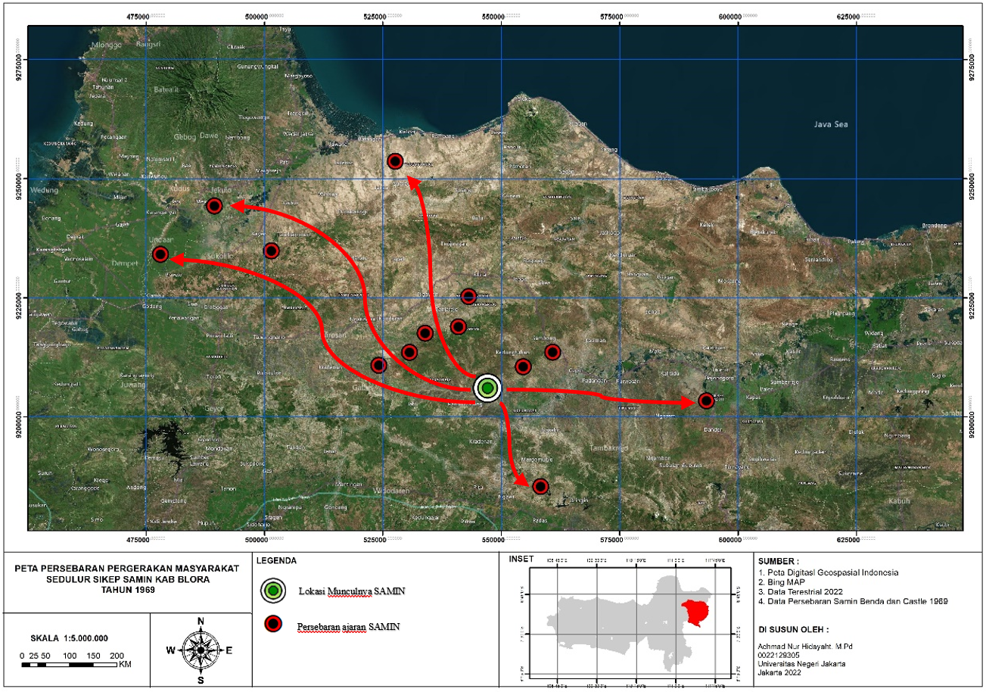
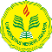
Figure 1. Map of the distribution of Samin's teachings in 1969
Blora
Ngawi
Demak
Pati
Rembang
Bojonegoro
Source : Benda & Castle (1969)

The development of the Samin community at the beginning of its appearance based on a report from Jesper in 1917 illustrates that the Samin teachings are growing quite rapidly, this is evidenced by its spread covering the Kab. Rembang, Kab. Pati, Kab, Kudul up and also to Kab. Bojonegoro, but Widyarini's (2006) research revealed that there is not much historical evidence that reveals the development of Samin's teachings at the beginning of the independence period. However, according to several prominent Samin bangkrek mbah lasiyo who were interviewed, many Samin people at that time did not know that their nation was already independent. So they are still closed and uncooperative with the authorities. In the village of Klopoduwur Blora from the time of independence until 1965, Samin's teachings were still developing. However, after this year Samin's movement in the village was not seen clearly. When the PKI rebellion broke out in 1965, many Samin figures were arrested, accused of being involved in the movement. This condition is increasingly cornering the existence of the Samin people.
However, currently in the era of globalization, the Samin community can still exist, observations in the field still show that there are groups of people who still believe in Samin's teachings. up to now, the Samin Blora community has practiced this, including: a) abstinence from being jealous (making slander); b) should not be srei (greedy); should not be hot (irritable or hate others); c) may not be da'wen (accusing without evidence); d) must not be cool (envy/shirk, desire to own things owned by others); e) not allowed to nyiyo marang sapodo (do insults against fellow inhabitants of nature); f) can not bedok (accusing); g) must not be stolen (stealing); h) may not be petil (taking goods that are still integrated with nature or are still attached to their source of life); i) may not jump (take what has become a commodity in the market); j) cannot find (finding goods is a taboo).
The following are the locations of the Samin community areas that still exist and still exist and interact and have activities, even taking part in socio-cultural activities in Blora Regency including:

Table 1. Location of Sedulur Sikep Samin Blora Masyarakat Community
No | Districts | Village | Geographical location | Samin Figure
1 | Sambong | Sambongrejo | 7° 6'15.74"S, 111°32'18.25"E  alt 64 meter | Mbah Pramugi Prawiro Wijoyo
2 | Banjarejo | Kelopo Duwur | 7° 2'16.28"S, 111°24'24.38"E  alt 104 meter | Mbah Lasiyo
3 | Randu Belatung | Kedhiren | 7°11'14.52"S, 111°24'59.85"E  alt 53 meter | Mbah Gunretno
4 | KKedung Tuban | Kemantren | 7°11'40.88"S, 111°31'4.26"E  alt 40 meter | Mbah Nyamu
Source : Prime Data

The Samin community in Sambongrejo Village was pioneered by Siman Surowijoyo around 1890. Siman Surowijoyo was a student and accomplice of Samin Surosentiko. Siman Surowijoyo is usually given the name Ki Engkrek who spread Samin's teachings to various regions. The Samin people live in groups in one hamlet, making it easier for them to communicate. The surrounding environment, family especially parents and peers have a big influence on the Samin community. The generation of Samin after Siman Surowijoyo was inherited by Tarman Turnowijoyo. With increasing years and ages, the next Samin chairman in 1921 was named Karmidi Karsodijoyo who had a great influence on the development of Samin's education. After Karmidi died, in 1977 until now the next chairman of Samin is Mbah Pramugi.
Sambongrejo village is currently one of the tourist villages in Sambong District, Blora Regency. One of the main destinations in this village is the Sedulur SIKEP literacy village or better known as Samin village which is located in Blimbing hamlet. The existence of the Samin community in this village has begun to develop with the creation of a tourist village, tourists will be invited to get to know, have dialogue, interact with Samin residents, learn from the honesty and simplicity of the Samin community. In addition, tourists will also be treated to the arts of the Samin Citizens in the form of Gejog Lesung, the original culinary of the Samin residents, and many other tourism potentials, such as learning to make batik, enjoying the beauty of rice fields, visits to historical places, and also visits to Etawa goat farms.
The majority of the Samin community in Klopoduwur village live in the southernmost area of ​​the Klopoduwur hamlet which is directly adjacent to the state forest. Lestari (2013) The distance is about 1 km from the village of Klopoduwur, and 200 meters from the highway. Administratively, Klopoduwur village is included in the Banjarejo sub-district, Blora district. The northern part is bordered by the village of Gedongsari, the western part by the village of Sumber Agung, the southern part by the village of Sidomulyo and the eastern part by the villages of Ngampon and Japan Rejo. To get to this village there is access to a paved road that has been passed by a bus route to Randublatung. The topography of this area is flat and wavy, at an altitude of 53 m above sea level. The total area of ​​Klopoduwur village is 687.70 hectares, most of the samin groups in this village are categorized as old people.
Apart from Sambongrejo and Kelopo Duwur, the Samin group still existed in their homeland in the village of Ploso Kedhiren, Randublatung, Blora, in 1859. The Samin has five brothers. The community of his followers who followed his teachings became known as Saminism until now, calling themselves Sedulur Sikep. The 100th anniversary of Samin Surosentiko in Randublatung, Blora, Central Java. Tuesday Kliwon, March 15, 2022 at Pendopo Pengayoman, Ploso Kediren, Randublatung, Blora - Central Java.

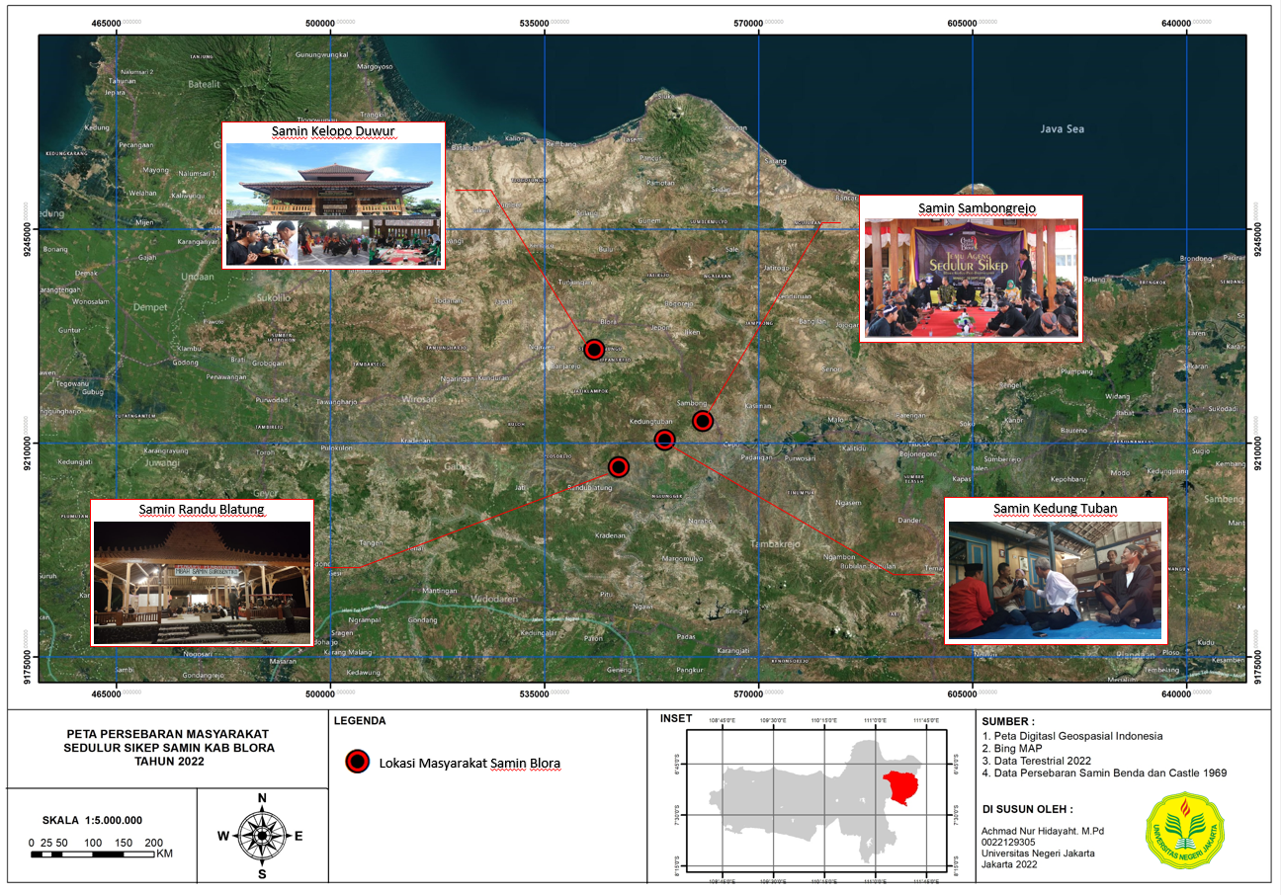
Figure 2. Location of the distribution of the Samin community in Blora Regency.
Source: Field Survey Data

The last location is Saminism in the Kemantren Village, especially in Dukuh Tanduran in Kedung Tuban District, according to Yahya (2009) history was brought by Surohidin with his wife named Samsiyah (daughter of Ki Samin Surontiko). Surohidin is a student and son-in-law of Samin Surontiko who is active and persistent in spreading Samin's teachings to various regions. Apart from these two, Saminism was also brought by his other children, namely Karto Kemis, the first child of Ki Samin, Radimah and Sabi'ah, all of whom live in Hamlet Tanduran, Kemantren Village, Kedungtuban District, Blora Regency.
The distribution of the Samin community, as described above, has the consequence that they feel more united who are bound by kinship bonds, and the Samin people call them seduluran. With this brotherhood, the Samin people admit that everyone is a brother (brother), especially with fellow Samin people. However, at this time it is not known with certainty the number of Samin people in Blora Regency, this is because there is no definite record, besides that people from within and outside the Samin are free to choose to join or go to find other jobs. According to the latest data in 2017 from the records put forward by Mbah Pramugi, he emphasized that currently there are around 2,217 Samin residents in Blora and continue to grow spread over 16 sub-districts, the most of which are in Sambong, Kedungtuban, Kradenan, Randublatung and Banjarejo sub-districts.

4. Conclusion
The Samin Surosentiko Blora community has become an inseparable unit. The distribution of the Samin community extends beyond the Blora Regency area, there are two reasons that explain this spread, which was carried out by Samin Surosentiko himself, assisted by his students. illustrates that the teachings of Samin are developing quite rapidly in Blora Regency. This is shown by the Samin community base which is still widely found covering 4 areas in Blora district, namely: (1) Kelopo Duwur Village, Sub-district of Blora, (2) Kemantren Village, Kedung Tuban District, (3) Sambongrejo Village, Sambong District and (4) Ploso Kediren Village, Randublatung District and continues to grow spread across 16 sub-districts in Blora Regency.

Acknowledgment
This research can be carried out smoothly with the help of the indigenous people of the Samin community or Sedulur Sikep Blora Regency and parties who cannot be mentioned one by one who wish to cooperate as informants who will be interviewed in the implementation of this research.
.

References
Aziz, Munawir.2012. Identitas Kaum Samin Pasca Kolonia Pergulatan Negara, Agama, dan Adat dalam Pro-Kontra Pembangunan Pabrik Semen Di Sukolilo, Pati, Jawa Tengah” Jurnal Kawistara, Vol. 2, No. 3, Desember 2012, h. 252-263.
Benda HJ, Castle L. 1969. The Samin Movement. In: Bijdragen toot de Taal-, Land- en Volkenkunde 125; 2: 207-240
Faturrohman, Deden, (2003), Hubungan Pemerintahan dengan Komunitas Masyarakat Samin, dalam Agama Tradisional : Potret Kearifan Hidup Masyarakat Samin dan Tengger, LKiS, Yogyakarta.
Hutomo, Suripan Sadi. (1996). Tradisi dari Blora, Semarang: Penerbit Citra. Almamater.
J. Jumari, D. Setiadi, Y. Purwanto, and E. Guhardja, "Etnoekologi Masyarakat Samin Kudus Jawa Tengah," Bioma : Berkala Ilmiah Biologi, vol. 14, no. 1, pp. 7-16, Jun. 2012
King VT. 1973. Some observation of the Samin Movement of the North-Central Java: Sugestion for the theoretical Analisis of the dynamic of rural Unrest. In: Bijdragen tot de taal, Land-en Volkenkunde 129; 4:457-461
Letari, Indah Puji. (2013). Interaksi Sosial Komunitas Samin Dengan Masyarakat Sekitar. Jurnal Komunitas, Vol 5 (1) (2013) : 74-86
Mokudi, Burhanuddin.A. 2016. Islam Abangan Dan Nasionalisme Komunitas Samin Di Blora Walisongo: Jurnal Penelitian Sosial Keagamaan, Vol. 24 No. 2, November 2016, 379-400
Mumfangati T, et al. (2004). Kearifan Lokal di Lingkungan Masyarakat Samin kabupaten Blora Jawa Tengah. Yogyakarta: Penerbit Jarahnitra
Munawaroh, D. (2015). Etnografi Masyarakat Samin di Bojonegoro: Potret Masyarakat
Samin dalam Memaknai Hidup Pelestarian Nilai Budaya. Balai Pelestarian Nilai Budaya.
Muhaimin AG, (2009), Gerakan Samin dan Misteri Agama Adam, dalam Jurnal Harmoni, Profil Aliran/Faham Keagamaan di Indonesia, Volume VIII, Nomor 30 April-Juni, Puslitbang Kehidupan Keagamaan, Badan Litbang dan Diklat Departemen Agama RI.
Octaviani. Emillia Vinna (2015). Pola Komunikasi Suku Samin di Kabupaten Blora Terkait Ajaran yang Dianutnya. Jurnal The Messenger, Vol. VII, No. 2, Juli 2015, h. 28.
Onghokham, (2002), Dari Soal Priyayi Sampai Nyi Blorong, Refleksi Sejarah Nusantara, Penerbit Buku Kompas, Jakarta.
Peluso, Nancy Lee, (1992), Rich Forest Poor People : Resource Control and Resistance in Java, New York : University of California Press.
Rohman, A. 2010. Romours and Realities of Marriage Practices in Contemorary Samin Society. Jurnal Humaniora. 22(2): 113-124.
Santoso, Hery. (2004). Perlawanan di Simpang Jalan: Kontes Harian di Desa-desa Sekitar Hutan di Jawa, Damar : Yogyakarta.
Sartini, (2009), Mutiara Kearifan Lokal Nusantara, Kepel Press. Yogyakarta.
Sastroatmodjo SRPA. 2003. Masyarakat Samin, Siapakah Mereka? Yogyakarta: Narasi
Soekanwo A. 1968. Masyarakat Samin. Yogyakarta: Fakultas Sastra dan Kebudayaan UGM
Suparni, Sri. (1993), Ajaran Etika menurut Serat Jamus Kalimasada (Kaum Samin), Fakultas Filsafat, UGM, Yogyakarta.
Widodo, Amrih, (2000), Untuk Hidup Tradisi Harus Mati, dalam Majalah Basis, Nomer 09-10 Ke-49, Yogyakarta.
Widyarini E. 2008. Saminisme Klopoduwur; Perubahan sosial komunitas Samin di Blora tahun 1968-1999. Yogyakarta: Fakultas Ilmu Budaya UGM
Yahya, ismail.(2009). Dentitas Dan Kearifan Lokal “Islam Samin” Di Era Global. Jurnal Millah Vol VIII No 2 Februari 2009

