Analysis of Junior High School Students' Ability to Read the Qur'an Based on Their Learning Environment Support

Muhammad Rizqi¹, Zainap hartati², Abdullah³
^{1,3}Faculty of Tarbiyah and Teacher Training, UIN Palangka Raya, Palangka Raya, Indonesia
²Faculty of Ushuluddin, Adab, and Dakwah, UIN Palangka Raya, Palangka Raya, Indonesia
E-mail: ¹muhammadrizqi2211110069@iain-palangkaraya.ac.id*, ²zainaphartati@iain-palangkaraya.ac.id@mail.com , ³abdullah@iain-palangkaraya.ac.id
*Corresponding Author

Article History:
Received: June 10, 2025; Revised: July 6, 2025; Accepted: July 9, 2025; Published: July 31, 2025

ABSTRACT

This study aims to analyze the ability of junior high school students to read the Qur'an based on their learning environment. Using a descriptive qualitative approach, data were collected through observation, in-depth interviews, and documentation of 10 seventh-grade students, Islamic Education teachers, the Deputy Head of Student Affairs, and the Principal. The results of the study indicate that the absence of programs to encourage Quran reading at school, limited time for religious education, and a lack of support and guidance from parents are the main factors contributing to students' low ability to read the Quran. Additionally, limited facilities such as the availability of Quran manuscripts at home and an unsupportive social environment further exacerbate the situation. These findings emphasize the importance of collaboration between schools, families, and communities in fostering sustainable Quran reading habits, through the implementation of special programs at schools, increased parental involvement, and the provision of adequate learning facilities. With collective efforts, it is hoped that students' Quran reading skills will develop optimally and support character development and the quality of religious education at junior high schools.

Keywords: Qur’anic Reading Skills, Junior High School Students, Causal Factors, Reading Habits, Learning Environment

 | Copyright © 2025 The Author(s)  This is an open-access article under the CC BY-SA license.

INTRODUCTION
The ability to read the Qur'an is a fundamental skill that every student must possess in Islamic religious education. Previous studies such as those by Fitriani et al. (2024), Harta (2020), Hartati et al. (2016), Lutfi et al. (2024), and Nurkholifah (2024) have proven that this skill is one of the most important aspects of religious education. In addition to being a source of teachings and guidelines for Muslims, the Qur'an also plays a major role in shaping the character and morals of students (Kusmita et al., 2024; Mansur (2024), Astuti & Abdullah, 2024: Lutfi et al., 2024). Therefore, mastering the art of reading the Qur'an properly and tartil is a key requirement that must be mastered from an early age so that students are able to understand and practice Islamic teachings correctly (Ihsanuddin et al., 2024; Nasution, 2024; Oktafera & Nasution, 2025; Wahdarohmah & Abdullah, 2024). This ability is not limited to technical aspects such as reading letters and tajwid, but also includes understanding the meaning and appreciating the values contained therein (Saputra & Subki, 2024; Nurhalizah et al., 2023; Hanafi et al., 2024; Saleh, 2025; Hartati, 2017).
Learning to read the Qur'an has become an integral part of the Islamic education curriculum at various school levels in Indonesia. This is reinforced by the implementation of Qur'an reading lessons at the junior high school level, as reflected in study Kartika & Alfurqan (2022) and Rizqi et al. (2024). Junior high schools have a responsibility to equip their students with adequate Quran reading skills. However, based on the results of observation and learning evaluation, there are still indications that most junior high school students have difficulty mastering Quran reading skills optimally. This condition is a serious concern given the importance of these skills in supporting the quality of religious education and character building of students.
The lack of ability to read the Qur'an among students can have a negative impact not only on their academic performance in religious studies but also on their motivation and interest in further studying the Qur'an. Previous studies such as those by Khoirurrizki & Bustam (2023), Munawaroh et al. (2023), and Japeri et al. (2023) indicate that this issue can indeed reduce students' enthusiasm for learning in religious education. Various factors are thought to be the main causes, such as teaching methods that lack variety and interest, limited learning facilities, teachers' inadequate competence in teaching the Qur'an, and minimal support from families and schools (Febrian et al., 2025; Putra et al., 2024; Rahma et al., 2025; Rizki et al., 2022; Sastraatmadja et al., 2024). This situation requires in-depth analysis so that appropriate and effective solutions can be found (Ansyah et al., 2025).
Research on the factors influencing students' ability to read the Qur'an has been extensively conducted, both at the elementary and secondary school levels. Studies conducted by Alif et al. (2021) and Mubi et al., (2024) emphasize the importance of innovative teaching methods, the role of competent teachers, and environmental support as key factors in improving the ability to read the Qur'an. However, there is still a lack of research specifically addressing the causes of low Qur'an reading ability in certain junior high schools, so this study is expected to fill that gap through more in-depth and contextual analysis.
This study has significant value both academically and practically. Academically, the findings of this study are expected to contribute to the development of Islamic education, particularly in the field of Quranic reading instruction. Practically, the research findings can serve as a basis for evaluation and improvement for teachers and school administrators in designing more effective teaching strategies, while also providing guidance for education policymakers to enhance the quality of religious education in junior high schools and other schools facing similar challenges.
Thus, this study aims to conduct a comprehensive analysis of junior high school students' ability to read the Qur'an, so that it can provide appropriate recommendations to improve the quality of Qur'anic education in these schools.

METHODS
This study employs a qualitative approach with a descriptive research design to gain an in-depth understanding of the phenomena at junior high schools from November 2024 to May 2025. The research population consists of 13 individuals, including 10 seventh-grade students, one Islamic Education teacher, one Vice Principal for Student Affairs, and one School Principal, all selected through purposive sampling based on their key roles in the educational process. Data were collected using structured observation sheets to record students’ use of learning media and classroom behavior, in-depth interviews guided by open-ended questions exploring learning motivation, media use, and academic achievement, as well as documentation such as class schedules, attendance lists, academic records, and photographs of learning activities. The instruments used included observation sheets, interview guidelines, and documentation formats. Data analysis was conducted qualitatively following the Miles & Huberman (1994) model, which consists of data reduction, data display, and conclusion drawing or verification, without the use of statistical methods or quantitative analysis software, given the interpretative nature of this research. Data validity was ensured through source and technique triangulation as recommended by Moleong (2017), while research ethics were maintained by obtaining official permission, ensuring participant confidentiality, and respecting privacy throughout the research process.

RESULTS AND DISCUSSION
Results
Based on observations, there are no regular activities for reading the Qur'an at junior high schools. There are no morning recitation programs, tahsin classes, or scheduled Qur'an literacy activities before or after lessons. Students only read the Qur'an during Islamic Education lessons, and even then, the time is very limited, averaging only 15–20 minutes per session.
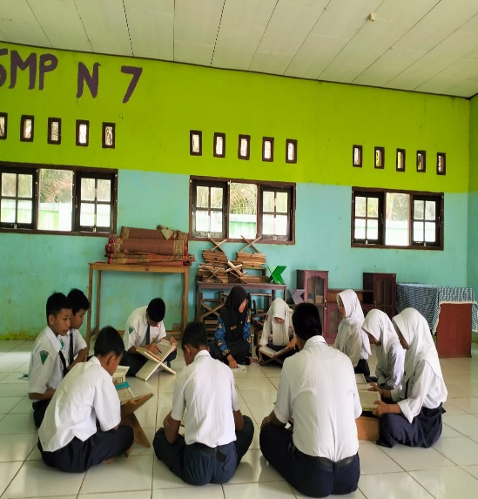
Figure 1. Al-Qur'an reading activities

From interviews with ten students, data was obtained showing that seven students rarely read the Qur'an outside of school. They admitted that they were not motivated to practice because there were no group activities at school and no study buddies at home. One student said, “I rarely read the Qur'an, except during religious studies lessons. At home, no one encourages me to read it, and my friends rarely do either.” Additionally, six students reported not receiving support from their parents. Some parents cannot read the Quran, while others are too busy working to ever ask or guide their children in reading it. One student said, “My parents can’t read the Quran, so I learn on my own. Sometimes I’m lazy because no one reminds me.”
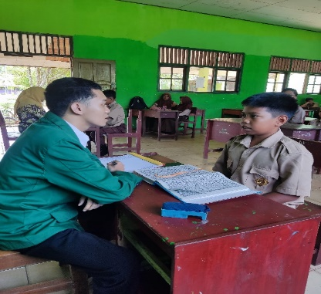
Figure 2. Interview with Students

Learning facilities are also an obstacle. Of the ten students, four do not have their own copies of the Qur'an at home. They can only read it at school or if they borrow it from a friend. Students who do not have a copy of the Qur'an tend to practice less frequently.
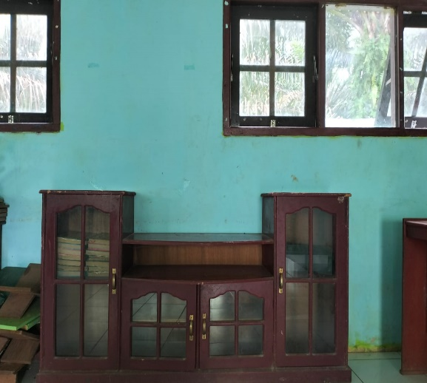
Figure 3. The Qur'an Mushaf at school

The PAI teacher emphasized that the limited time allocated for religious studies meant that the process of teaching students to read the Qur'an could not be carried out to the fullest extent. The teacher said, “The time is very limited, especially since there is no special program for familiarization. Students only rely on PAI lessons, but that alone is not enough.”
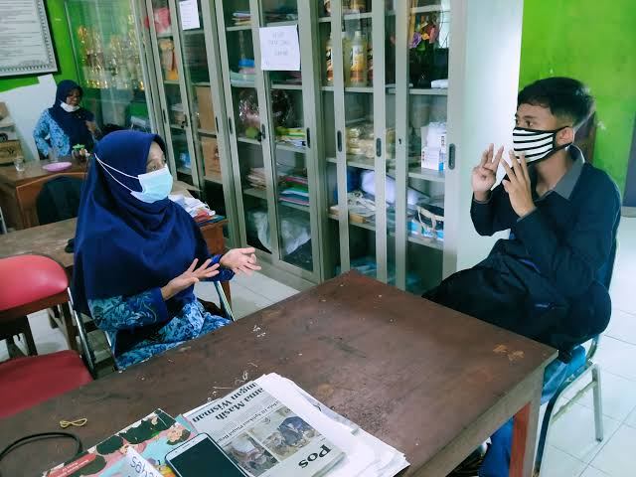
Figure 4. Interview with PAI teachers

The Deputy Principal and Principal acknowledged that the school does not yet have a program to encourage students to read the Qur'an due to time constraints, a lack of teaching staff, and a focus on other academic activities. They are aware that the absence of such a program has led to low student interest and ability. The Principal stated, “We do not yet have a specific program for the habit of reading the Qur’an. Our focus is still on academics. However, we recognize that such a program is necessary in the future.”
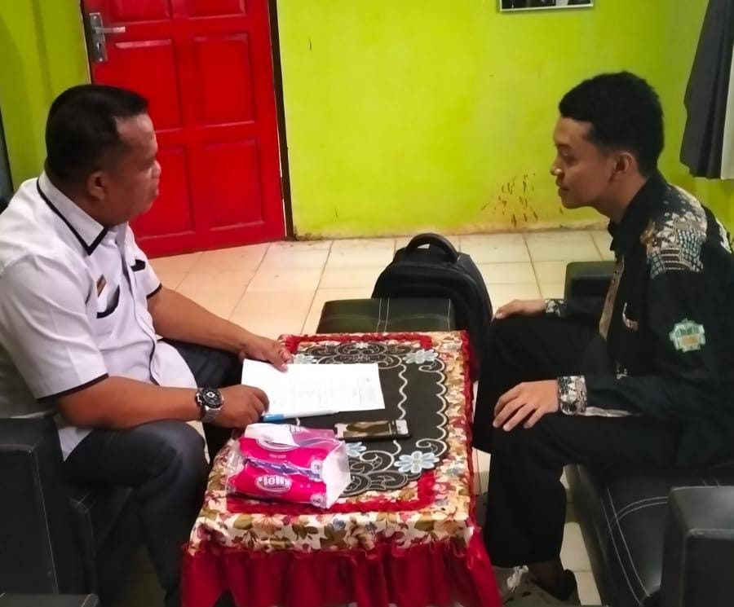
Figure 6.
Interview with the principal

Overall, the results of the study indicate that the absence of activities to encourage reading the Qur'an at school has a direct impact on students' low motivation and ability to read the Qur'an. This condition is exacerbated by a lack of family support and limited facilities at home. These findings emphasize the need for joint efforts between schools and families to create better habits of reading the Qur'an among students.

Discussion
The results of this study indicate that the low ability to read the Qur'an among junior high school students is mainly due to a lack of internal motivation, insufficient family support, an unsupportive social environment, and limited learning facilities. These findings align with the theory of internal and external factors influencing the ability to read the Quran, where internal factors include motivation, interest, and students' psychological conditions, while external factors encompass family support, social environment, and learning facilities (Fathullah Faris et al., 2023; Abdullah et al., 2021; Muthmainah & Usman, 2022; Elvina et al., 2021; Munzir, 2023)
Learning motivation has been proven to be one of the key factors. Research by Kahfi et al. (2024) emphasizes that learning motivation does indeed have a significant effect on the ability to read the Qur'an, but its contribution is still low. Therefore, support from families and schools is essential so that students practice reading the Qur'an more often, thereby improving their mastery of tajwid and fluency in reading students with low motivation tend to practice infrequently and have poor reading skills. In addition to the above research, Tazkirah et al. (2025) In his research, he argues that teachers' competence in understanding and teaching tajwid does indeed have a significant influence on the quality of Al-Qur'an education, but its contribution is still limited without adequate support. Therefore, institutional support, structured training, and adequate learning resources are crucial for teachers to continuously improve their tajwid skills and teaching strategies, thereby enhancing students' mastery of tajwid and overall Quran reading ability. Teachers with limited competencies and support often face challenges in delivering effective tajwid instruction, which can hinder students' learning outcomes.
Family support is also an important factor. The results of this study found that most parents are unable to guide their children in reading the Qur'an, either due to limited abilities or time constraints. Research by Azwar (2024) and Hanafi & Pohan (2024) show that a supportive family environment, parental involvement, and a routine of reading the Quran together can significantly improve children's ability to read the Quran. Conversely, a lack of attention and guidance from the family has a negative impact on the development of students' ability to read the Quran.
The social environment also has a significant influence. Research by Gaya & Ahmad (2024) shows that Muslim youth who are in supportive environments, such as peers who share and practice Islamic values, tend to have a stronger sense of Islamic identity and are more resilient in the face of external pressures such as peer pressure, materialism, and Islamophobia. Conversely, those in less supportive environments may face greater challenges in maintaining their religious identity, which can lead to weakened beliefs or engagement in behaviors contrary to Islamic teachings. These findings emphasize that the social context plays a substantial role in shaping and maintaining the Islamic identity of Muslim youth, serving as a foundation that helps them navigate contemporary challenges
In addition, limitations in learning facilities, such as the absence of Al-Qur'an manuscripts at home, also pose obstacles, as found in this study. Nisa et al. (2021) emphasize the importance of adequate learning facilities to support the process of learning to read the Al-Qur'an at home and at school. This facility factor is further supported by findings from various other studies, such as those by Asmariyah et al. (2024), Hidayat et al. (2022) and Khotimah & Maslikhatun (2024), which indicate that students with easy access to the Quran tend to practice more frequently and master reading more quickly
From a learning strategy perspective, previous studies such as that by Ibnu et al. (2023) recommend the application of the talaqqi and tahsin methods, as well as the use of interactive digital media, as efforts to improve the quality of students' reading. However, this study found that special programs for practicing reading the Qur'an in schools are still very limited, so that students' learning time is very limited to religious education classes only. This contrasts with practices in schools or institutions, as observed in the study by Khotimah & Maslikhatun (2024), which states that the combination of cooperative learning and blended learning approaches not only equips students with the ability to understand the material but also enhances communication skills, interpersonal skills, problem-solving, critical analysis, and other skills needed by students. With the ease of technology, the limitations of classroom meetings can be overcome through blended learning.
Thus, the results of this study reinforce previous findings that motivation, family support, social environment, learning facilities, and innovative learning strategies are factors that greatly determine students' success in reading the Qur'an. Therefore, efforts to improve students' ability to read the Quran in junior high schools must be comprehensive, involving schools, families, and the surrounding community, and supported by appropriate habit-forming programs and adequate learning facilities.

CONCLUSION
Based on the results of the study, the ability to read the Qur'an among junior high school students is still relatively low. This condition is influenced by the absence of a regular program for practicing reading the Qur'an at school, limited time for religious education, lack of support and guidance from parents, low student motivation, limited access to Qur'an manuscripts at home, and an unsupportive social environment. These factors are interrelated and constitute the main obstacles to the development of Quran reading skills among junior high school students.
As a recommendation, schools are encouraged to initiate special programs that promote the habit of regularly reading the Quran, such as morning Quran recitation sessions or Quranic recitation classes, and provide training to teachers to enable them to apply more varied and engaging teaching methods. Parents are also encouraged to be more active in accompanying and motivating their children to read the Quran at home, at least by providing adequate time and facilities. Additionally, the community can play a role by creating a supportive social environment through joint religious activities.
This study has a number of limitations that need to be considered. One of them is that the study was only conducted in one junior high school, so the findings obtained cannot yet represent other schools with different characteristics. Additionally, this study did not involve parents as data sources, despite the significant role of families in supporting the process of Quran literacy. The aspect of community involvement was also not extensively explored in this study. Therefore, future research is recommended to develop and test various intervention programs, such as the use of digital media or the implementation of community-based learning models, to enhance students' Quran literacy. Furthermore, the scope of the research should be expanded to other schools with diverse backgrounds and characteristics to make the results more representative and generalizable. Future research is also expected to involve collaboration between schools, families, and communities, such as interviewing parents and community leaders, to gain a more comprehensive understanding of the factors influencing Qur'an literacy. Furthermore, exploring effective collaboration strategies between schools, families, and communities in creating a learning environment that supports the development of Quran literacy is also very important. By considering these limitations and recommendations, it is hoped that future research can provide a more comprehensive contribution to improving Quran literacy among secondary school students.
With synergy and sustained efforts from various parties, it is hoped that students' ability to read the Qur'an in junior high schools will improve, thereby supporting the development of character and the overall quality of Islamic religious education.

CONFLICT OF INTEREST
The authors declared that they have no conflicts of interest.

REFERENCES
Abdullah, N. M. S. A. N., Sabbri, F. S. M., & Isa, R. A. M. (2021). Exploring Student Motivation in Quranic Memorization in Selected Islamic Secondary Schools (a Case Study). Al-Hayat: Journal of Islamic Education, 5(1), 100. https://doi.org/10.35723/ajie.v5i1.161
Alif, M., Nuryana, Z., Yuliana, A. T. R. D., & Rahman, A. (2021). Innovative Learning Strategies and Methods to Overcome Difficulties in Reading the Qur’an. Al-MISBAH (Jurnal Islamic Studies), 9(2), 140–151. https://doi.org/10.26555/almisbah.v9i2.3908
Ansyah, A., Amin, S. J., Marhani, M., Nurhayati, N., & Herdah, H. (2025). Analisis Kemampuan Baca Al Qur ’ an dan Faktor yang Mempengaruhinya di Madrasah Aliyah DDI Attaufiq Padaelo Kecamatan Tanete Rilau Kabupaten Barru. Iqra: Jurnal Ilmu Kependidikan Dan Keislaman, 20(01), 127–133. https://doi.org/10.56338/iqra.v20i1.6868
Asmariyah, A., Supriyanto, A., & Sobri, A. Y. (2024). The Influence of Learning Facilities on Students’ Academic Achievement at the International Islamic Boarding School Malang. JMSP: Jurnal Manajemen Dan Supervisi Pendidikan, 9(1), 164–168. https://doi.org/http://dx.doi.org/10.17977/um025v9i12024p60
Astuti, M. S., & Abdullah. (2024). Pendampingan Penerapan Metode Tilawati Pada Siswa Tadarus MAN Kota Palangka Raya. Pengabdian Masyarakat Bangsa, 2(8), 3614–3621. https://doi.org/10.59837/jpmba.v2i8.1527
Azwar, B. (2024). Collaborative Efforts of Counseling Teachers in Enhancing Self- Happiness Among Qur ’ an- Memorizing Students : A Case Study. Al-Ishlah: Jurnal Pendidikan, 16(4), 5243–5253. https://doi.org/10.35445/alishlah.v16i4.5763
Elvina, E., Ritonga, M., & Lahmi, A. (2021). Islamic Parenting and Motivation from Parents and Its Influence on Children’s Ability to Read the Quran. Jurnal Tarbiyatuna, 12(2), 121–134. https://doi.org/10.31603/tarbiyatuna.v12i2.4996
Fathullah Faris, A., Nur Hadis Rahman, S. A., Talhah Jima, M., Sobri Faisal, M., & Raehan Mustafa, R. (2023). Quranic Reading Proficiency and Factors Affecting Mastery Quran among Public University Students. BITARA International Journal of Civilizational Studies and Human Sciences, 6(4), 127–138. https://doi.org/https://bitarajournal.com/index.php/bitarajournal/article/view/415
Febrian, L. M., Florentina, T., Qolbi, A. D., & Efendi, S. (2025). Peningkatan Kemampuan Membaca Al-Qur’an Melalui Pengajaran Mengaji pada Siswa SMPN 4 Kota Bengkulu. Fakultas KEguruan Dan Imu Pendidikan Universitas Kristen Indonesia, 6(1), 648–661. https://doi.org/https://ejurnals.com/ojs/index.php/jdpn/article/view/1397/1637
Fitri Rahmawati, I., Asma, Assyifa Saputri, K., Nisa, L., Siti Nurjanah, L., Nurhayati, R., Qamara Azizah, R., Sulistiawati, & Paloh, S. (2024). Kemampuan Membaca Al-Quran Berdasarkan Gender Pada Fakultas Kedokteran Angkatan 2023 di Universitas Sultan Ageng Tirtayasa. Jurnal IHSAN Jurnal Pendidikan Islam, 2(2), 52–59. https://doi.org/10.61104/ihsan.v2i2.117
Fitriani, F., Susanti, W., & Putri, N. (2024). Five Challenges of Quran Learning in Islamic Education Institutions. Journal of Quranic Teaching and Learning, 1(1), 1–10. https://doi.org/https://joqer.intischolar.id/index.php/joqer/article/view/4
Gaya, S., & Ahmad, N. (2024). The Concept of Islamic Identity and Its Importance for Muslim Youth. Jurnal Hukum Pidana Dan Ketatanegaraan, 13(1), 34–49. https://doi.org/10.24252/al-daulah.
Hanafi, M. A., Somad, M. A., Romli, U., & Almasi, M. (2024). Strategy to Improve al-Quran Reading and Writing Skills in Public Schools. Journal of Islamic Education Research, 5(3), 239–252. https://doi.org/10.35719/jier.v5i3.450
Hanafi, M., & Pohan, S. (2024). Enhancing Quranic Literacy : The Role Teacher and Parental Involvement in Quran Learning. FIKROTUNA; Jurnal Pendidikan Dan Manajemen Islam, 14(2), 189–202. https://doi.org/http://dx.doi.org/10.32806/jf.v14i2.611
Harta, M. (2020). Role of Al-Qur’an Read and Write Ability toward Achievement of Islamic Education for Students at SDN Inpres 12/79 Kampuno Attobaja Village Barebbo Sub-District Bone Regency. Journal of Islam and Science, 7(1), 49–54. https://doi.org/10.24252/jis.v7i1.15035
Hartati, Z. (2017). Tasyrifin Karim, Merintis Pengembangan Baca Al-Qur‟An Untuk Orang Dewasa (1st ed.). FTIK IAIN Salatiga. http://digilib.iain-palangkaraya.ac.id/1669/1/PROCEEDINGS%20ICIIES%20-Book%20TWO.pdf
Hartati, Z., Emawati, E., & Dalimunte, L. A. (2016). Metodologi Baca Tulis Al-Quran: Refleksi Belajar Al-Quran Pada Mahasiswa IAIN Palangkaraya. MISYKAT: Jurnal Ilmu-Ilmu Al-Quran, Hadist, Syari’ah Dan Tarbiyah, 1(1), 181. https://doi.org/10.33511/misykat.v1n1.181
Hidayat, S., Amirsyah, A., Affandi, L., & Rahmat, M. (2022). The Impact of the Digital Al-Qur’an Thematic Learning Model on the Learning Achievement of Santri at Islamic Boarding Schools in Bandung Regency. QALAMUNA: Jurnal Pendidikan, Sosial, Dan Agama, 14(2), 947–960. https://doi.org/10.37680/qalamuna.v14i2.3764
Ibnu, M., Rahmawati, S., Ridwansyah, R. S., Kariadinata, R., & Susilawati, W. (2023). Influence of the Talaqi and Tahsin Methods on the Al-Qur’an Reading Ability of Santri at the Al-Falah Islamic Boarding School Nagreg Bandung. Journal of Modern Islamic Studies and Civilization, 1(03), 124–137. https://doi.org/10.59653/jmisc.v1i03.280
Ihsanuddin, I., Abdullah, A., & Jainah, J. (2024). Pelatihan Menulis Huruf Hijaiyah melalui Media Papan Flanel untuk Meningkatkan Keterampilan Menulis Huruf Hijaiyah Siswa di SD IT Al-Ghazali Palangka Raya. Jurnal Pelayanan Masyarakat, 1(4), 99–206. https://doi.org/10.62951/jpm.v1i4.921
Japeri, J., Rahmi, E., Izmi, N., Irayanti, I., & Eki Saputri, T. (2023). Identifying Student Motivation for Learning Islamic Education in Indonesian Senior High Schools. Ahlussunnah: Journal of Islamic Education, 2(1), 26–34. https://doi.org/10.58485/jie.v2i1.188
Kahfi, N. S., Raharjo, R., & Ikhrom, I. (2024). The Effect of Qiroati and Non Qiroati Methods in Improving Students ’ Ability to Read and Write the Qur ’ an at TPQ Al-Ikhlas. Journal on Education, 6(4), 22416–22423. https://doi.org/10.31004/joe.v6i4.6413
Kartika, M., & Alfurqan. (2022). Problematika Peserta Didik dalam Membaca Al-Qur’an di SMP Negeri 1 Lembah Melintang. Jurnal Pendidikan Tambusai, 6(2), 9378–9385. https://doi.org/10.31004/jptam.v6i2.3895
Khoirurrizki, A. A., & Bustam, B. M. R. (2023). Analysis of Low Interest in Reading the Qur’an in School Age Children. Jurnal Ilmu Pendidikan Dan Sosial, 1(1), 47–59. https://doi.org/10.58540/jipsi.v1i1.12
Khotimah, H., & Maslikhatun, N. (2024). Global Challenges in Elementary Qur’an Memorization Tantangan. Indonesian Journal of Law and Economics Review, 12(2), 6–13. https://doi.org/10.21070/ijis.v12i2.1718
Kusmita, R., Hartati, Z., & Alfajar, E. (2024). Pendampingan Metode Tilawati Untuk Meningkatkan Kualitas Membaca Al-Qur’an Di SMPN 8 Palangkaraya. GEMBIRA, 2(5), 1761–1769. https://gembirapkm.my.id/index.php/jurnal/article/view/678
Lutfi, S., Sardimi, S., & Norhidayah, S. (2024). Al Qur an Hadits (S. Surawan (ed.); Pertama). K-Media. https://doi.org/http://digilib.iain-palangkaraya.ac.id/5571/1/Buku%20Pembelajaran%20Al-qur%E2%80%99an%20Hadits_Saiful%20Lutfi%2C%20dkk.pdf
Mansur, M. (2024). The Impact of Quranic Education on Student Development at Amaliah Ciawi Bogor High School. Journal of Education: Development and Review (JEDAR), 1(2), 84–88. https://doi.org/https://pub.ruangrosadi.com/jurnal-ilmiah/index.php/jedar/article/view/22
Miles, M. B., & Huberman, A. M. (1994). Qualitative Data Analysis. In Sage Publication (Second Edi). Sage Publications. https://doi.org/https://vivauniversity.wordpress.com/wp-content/uploads/2013/11/milesandhuberman1994.pdf
Moleong, L. J. (2017). Metodologi Penelitian Kualitatif (36th ed.). Remaja Rosdakarya. https://doi.org/https://inlislite.uin-suska.ac.id/opac/detail-opac?id=12221
Mubi, Z. A., Hussin, H., & Mohamad, S. (2024). A Literature Highlight on Teachers Competency Level in Teaching Special Class on Quranic Recitation and Memorization Skills (KKQ). Jurnal Pendidikan Agama Islam, 17(2), 346–363. https://doi.org/10.14421/jpai.v21i2.8238
Munawaroh, A., Munawir, M., & Pavytha, V. I. (2023). Kurangnya Minat Remaja Dalam Belajar Al-Qur’an Akibat Pengaruh Canggihnya Teknologi Informasi. Al-Mau’izhoh, 5(2), 460–475. https://doi.org/10.31949/am.v5i2.7535
Munzir, M. (2023). Motivational Influences and Challenges in Quranic Recitation Proficiency: A Study Among Islamic Educational Teacher Training Department State Islamic University Ar-Raniry Banda Aceh Students. Jurnal Mudarrisuna: Media Kajian Pendidikan Agama Islam, 13(2), 262. https://doi.org/10.22373/jm.v13i2.22103
Muthmainah, M., & Usman, A. H. (2022). Family support for young Ḥāfiẓ Al-Qur’ān. Journal of Early Childhood Care and Education, 5(1), 27–44. https://doi.org/10.26555/jecce.v5i1.5974
Nasution, M. R. (2024). Asbāb al - Nuzūl Al-Qur ’ an and its Relevance to Islamic Education. Scaffolding: Jurnal Pendidikan Islam Dan Multikulturalisme, 6(3), 409–421. https://doi.org/10.37680/scaffolding.v6i3.7053
Nisa, F. K., Rido, M. A., Izharman, I., & Susanti, W. (2021). Problems of Teachers and Santri in Learning the Qur’an. International Journal of Multidisciplinary Research of Higher Education, 1(1), 1–11. https://doi.org/10.24036/ijmurhica.v4i1.152
Nurhalizah, S., Siahaan, A., & Fadhila Daulai, A. (2023). Implementation of the Al-Qur’an Literacy Program to Improve the Ability to Read the Al-Qur’an at the Al-Abid Islamic Elementary School in Medan. International Journal Of Humanities Education and Social Sciences (IJHESS), 3(2), 975–988. https://doi.org/10.55227/ijhess.v3i2.612
Nurkholifah, S. (2024). The Role of Al-Quran Literacy in Deepening Understanding of Islamic Religious Education. AFKARINA: Jurnal Pendidikan Agama Islam, 9(1), 47–60. https://doi.org/10.33650/afkarina.v9i1.9357
Oktafera, A., & Nasution, Z. (2025). Implementation Of The Quran Reading Program In Forming Students’ Disciplined Character. Scaffolding: Jurnal Pendidikan Islam Dan Multikulturalisme, 6(3), 333–352. https://doi.org/10.37680/scaffolding.v6i3.6411
Putra, R. S., Sinaga, A. I., & Nasution, S. (2024). Pengaruh Program Literasi Al-Qur’an dan Dukungan Keluarga terhadap Kemampuan Membaca Al- Qur’an Siswa SMP IT Permata Cendekia Kabupaten Simalungun. Ideguru: Jurnal Karya Ilmiah Guru, 9(2), 672–677. https://doi.org/10.51169/ideguru.v9i2.882
Rahma, E., Hertati, H., & A, M. (2025). Tantangan Dan Solusi Meningkatkan Kemampuan Membaca Al-Qur’an Siswa Di SMPN 9 Tualang. Review Pendidikan Dan Pengajaran, 8(1), 3400–3405. https://journal.universitaspahlawan.ac.id/index.php/jrpp/article/download/43586/27371/145690
Rizki, S. N., Ajahari, A., & Surawan, S. (2022). Peran Orang Tua Dalam Memotivasi Belajar Al-Qur’an Pada Anak Di Tpa Sidomulyokota Palangka Raya. Wahana Islamika: Jurnal Studi Keislaman, 164–177. https://doi.org/10.61136/pmm29y60
Rizqi, M., Faujianor, A., & Yuliani, H. (2024). Validitas Pengembangan Media Pembelajaran Bagan dan Audio pada Materi Wudhu. Attractive: Innovative Education Journal, 6(3), 414–422. https://doi.org/10.51278/aj.v6i3.1702
Saleh, F. (2025). The Role of Hadith in Enchancing Quranic Literacy. El-Sunan, 3(1), 1–23. https://doi.org/10.46870/jiat.v4i1.178.3
Saputra, R. A., & Subki, S. (2024). INTEGRATION OF QURANIC VALUES IN LEARNING STRATEGIES : Review of Interpretation and Implementation. Fitrah: Journal of Islamic Education, 5(2), 128–142. https://doi.org/https://doi.org/10.53802/fitrah.v15i2.921
Sastraatmadja, A. H. M., Emalis Saputra, A., Kulsum, S., Aini Farida, N., & Makbul, M. (2024). Meningkatkan Kemampuan Membaca Al-Qur’an Siswa Kelas Vii Smpit Abdan Syakuro Dengan Metode Al Muyassar. Mathematic Education JournalMathEdu, 7(2), 67–75. http://journal.ipts.ac.id/index.php/
Tazkirah, S., Ilham, I., & Nasaruddin, N. (2025). STRATEGY FOR DEVELOPING TEACHER COMPETENCE IN QUR ’ ANIC EDUCATION GARDEN IN THE MODERN ERA : Analysis of Understanding of Tajweed At-Tadzkir Teaching Content. Fitrah: Journal of Islamic Education, 6(1), 35–48. https://doi.org/https://doi.org/10.53802/fitrah.v6i1.1135
Wahdarohmah, N. K., & Abdullah. (2024). Pendampingan Membaca Al-Qur’an Sebelum Belajar Melalui Kegiatan Pengabdian Mahasiswa IAIN Palangka Raya. ARDHI : Jurnal Pengabdian Dalam Negri, 2(5), 133–139. https://doi.org/https://doi.org/10.61132/ardhi.v2i5.777

